Case Law Searcher 1.0
By Tammy Cravit, tammy@tammycravit.us

About Case Law Searcher

Case Law Searcher is a simple tool for online legal research. If you don’t have Westlaw or Lexis-Nexis access, Case Law Searcher will be a handy tool for looking up case law. The tool supports searching Federal and California appellate and Supreme Court decisions by citation, and can also search California appellate and Supreme Court decisions by party name or keyword.

Case Law Searcher aggregates a variety of online search tools, including OpenJurist.org, Precydent.com and FindLaw.

Before You Begin
If you don’t already have one, you’ll need to sign up for a free FindLaw.com account. You can register for a “FindLaw for Legal Professionals” account by visiting:

http://login.findlaw.com/scripts/register?dest=http://lp.findlaw.com/

Once you have a FindLaw account, continue to the next section to install the software.

Installing Case Law Searcher
Case Law Searcher ships as a single installer file, named CLSSetup.exe. To install it, simply double-click on the CLSSetup.exe file, which looks like this:

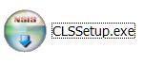
You’ll be guided through the installation process, after which the software will be started.

Beginning to use Case Law Searcher
When you first run Case Law Searcher, you may think nothing has happened. But if you look in your system tray (the area next to the clock in Windows), you’ll see a new icon which resembles a stack of books:

This icon is your entry into the program. Right-click on the icon, and a menu like the following will pop up:

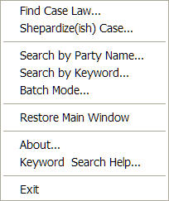

All of the functions in Case Law Searcher are directly accessible from this menu, as well as from the main window. To see the main window and learn about its functions, pick “Restore Main Window” from the pop-up menu.

The Main Window
When you pick Restore Main Window from the pop-up menu, you’ll see the Case Law Searcher dashboard. It looks like this:

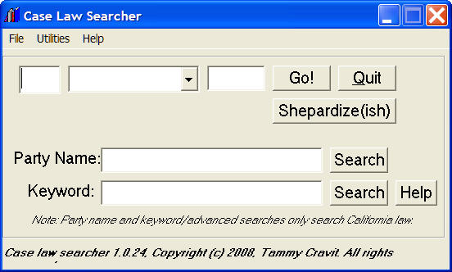
You can perform three kinds of search from this screen:

- Citation Search – Enter a citation into the citation builder on the top half of the window, and click Go! to search for that citation. The search results will be displayed in a Web browser, and the citation builder will reset itself for your next request. If you click the Shepardize(ish) button instead, you’ll be taken to a list of cases that cite the case whose citation you entered. (This isn’t real Shepardizing, because it doesn’t include the case treatment, headnote numbering and other advanced information from a true Shepard’s search, but it might help you find related cases.)
- Party Name Search – Enter a party name in the Party Name box and click its Search button to perform a search for cases including that party name. Again, the search results will be displayed in a Web browser window.
- Keyword Search – The keyword search box allows you to do much more advanced (and powerful) searches. You can simply enter a keyword in this box, or you can consult the Advanced Search Language section on page 4 to learn how to perform more sophisticated searches.

Batch Mode
Batch Mode allows you to enter a list of citations and open them all at one time. This is helpful if you’re reading a case (or reference book) that cites several precedents and you want to look at all of them. To access Batch Mode, pick the Batch Mode item from either the pop-up menu or from the main screen’s Utilities menu. You’ll see the Batch Mode screen, which looks like this:

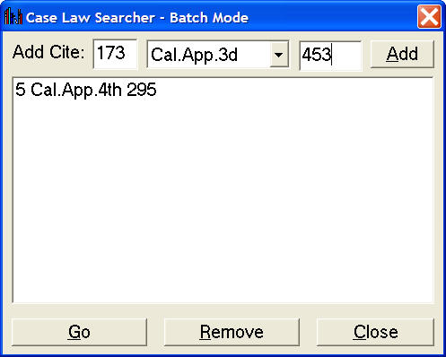

To add a case citation to the search list, fill in the citation builder at the top of the screen and click the Add button. To remove cases from the list (for example, if you mistype the citation), click the desired entry in the citation list. When you’re done entering your list of citations, click the Go button to open all your specified citations.

Advanced Search Language
The Keyword search function allows you to use a variety of special keywords to perform more advanced searches. The following is a quick reference to search keywords. For full details, consult FindLaw’s search help page:

http://www.findlaw.com/info/helpers/searchhelp.html

Search Type | If you enter… | You’ll receive…
Phrase | “juvenile dependency” | All cases containing the phrase “juvenile dependency”.
AND search (all keywords) | toxics and torts | All cases containing both the words “toxics” and “torts”.
OR search (any keyword) | toxics or torts | All cases containing “toxics”, “torts”, or both.
NOT search (negation) | toxics and not sewage | All cases containing the word “toxics” that don’t contain the word “sewage”.
NEAR search (proximity) | “de facto parent” near removal | All cases containing the phrase “de facto parent” within about 50 words of the word “removal”, ranked by how close together the words are.
Prefix search | star* | All cases mentioning a word that begins with “star” (starlight, starship, start, etc.)
Stemming search | fly** | All cases mentioning a word related to “fly” (flew, flown, flying, etc.)
Grouping | (a and b) or c | All cases containing either “c” or both of “a and b”.
 | (a near b) and not c | All cases containing the word “a” near the word “b” and not containing the word “c”.

Grouping allows you to combine these search keywords in more complex arrangements to suit your needs. The feature is perhaps not as powerful as Lexis-Nexis or Westlaw’s search facility, but you’ll find it quite powerful if you learn to use these keywords well.

Live Update
Case Law Searcher uses a configuration file (Sources.cfg) to determine which reporters are available for searching and how to access them. When the program first launches, it will attempt to connect to the Internet and download the latest version of this file. The file is quite small, and the live update process should normally be invisible to the user.

About the Author
Case Law Searcher was developed in Visual Basic 6 by Tammy Cravit, tammy@tammycravit.us. Tammy welcomes feature requests and feedback by e-mail.

Sharing Case Law Searcher
You may freely share and distribute Case Law Searcher, as long as you comply with the terms of the GNU General Public License, version 2. A copy of this license is installed along with the program, or you can read it online at:

http://www.gnu.org/licenses/old-licenses/gpl-2.0.html

The source code for Case Law Searcher is available via the git source code control system. To obtain the source code, issue the following git command:

git clone git://github.com/tammycravit/case-law-searcher.git

For more information about the git source code control system, visit the Git homepage:

http://git.or.cz/

